Copyright for test papers and marking guides remains with *West Australian Test Papers*.

The papers may only be reproduced within the purchasing school according to the advertised conditions of sale.

Test papers must be withdrawn after use and stored securely in the school until 12th October 2016.

**HUMAN BIOLOGY**

**Units 3 and 4**

**2016**



**ANSWERS**

**Note: This marking key has not been ratified so student responses outside those which have been provided can still be accepted if they are correct.**

**Section One: Multiple-choice 30% (30 Marks)**

This section has **30** questions. Answer **all** questions on the separate Multiple-choice Answer Sheet provided. For each question shade the box to indicate your answer. Use only a **blue or black pen** to shade the boxes. If you make a mistake, place a cross through that square, do not erase or use correction fluid, and shade your new answer. Marks will not be deducted for incorrect answers. No marks will be given if more than one answer is completed for any question.

Suggested working time: 40 minutes.

1. Many factors affect fossil formation. Which of the following environments is an organism **most likely** to be preserved as a fossil?
   1. Forest floor
   2. **Sea floor**
   3. Coastal beach
   4. Active glacier
2. A person’s brain is injured in an accident resulting in the person unable to regulate temperature, hunger and water balance. Which of the following parts of the person’s brain was affected?
   1. **Hypothalamus**
   2. Medulla Oblongata
   3. Cerebellum
   4. Forebrain
3. Select the **best** description of a virus.
   1. A non-cellular living organism
   2. A small form of bacteria
   3. A cell at the boundary between the living and non-living
   4. **Chemical complexes of RNA or DNA protected by protein**
4. Dermatitis is inflammation of the skin. Choose the best description of an inflammatory response.
   1. An internal non-specific defence as a response to invading pathogens.
   2. An antibody-mediated specific response to infection.
   3. A cell-mediated specific response to infection.
   4. **An internal non-specific defence as response to tissue damage.**
5. Which of the following strategies would help restore a high body temperature to normal?
   1. Goosebumps
   2. Redistribution of blood flow away from the periphery
   3. Piloerection
   4. **Sweating**
6. An increase in respiration rate is a homeostatic response to
   1. Decreased oxygen levels in the blood.
   2. Decreased carbon dioxide levels in the blood.
   3. Increased pH of the blood.
   4. **Increased concentration of hydrogen ions in the blood.**
7. Which of the following is true about synapses?
   1. Neurotransmitters bind to receptors on both the post- and pre-synaptic knobs, causing ion-specific channels to open.
   2. Only excitatory signals can be sent across synapses.
   3. **Neurotransmitter receptors at the synapse are coupled to ion-specific channels.**
   4. A neuromuscular junction is the synapse between a nerve and a gland.
8. A strong stimulus can increase the
   1. **Frequency of the action potentials.**
   2. The concentration of neurotransmitters within each vesicle.
   3. Minimal threshold needed for the all-or-none response.
   4. Speed of the impulse travelling down the axon.
9. For Natural Selection to occur, mutations must be
   1. **germline.**
   2. morphologic.
   3. somatic.
   4. autonomic.
10. Bactericidal antibiotics work by
    1. inhibiting the production of all enzymes.
    2. disrupting the process of protein synthesis.
    3. **disrupting the action of essential enzymes.**
    4. inhibiting bacteria from reproducing.
11. Gene therapy is a technique that has the ability to treat inherited diseases by
    1. **replacing faulty genes with healthy copies.**
    2. repairing the faulty gene.
    3. restoring healthy tissues or organs.
    4. removing the faulty gene.

Question 12 refers to the Karyotype below.

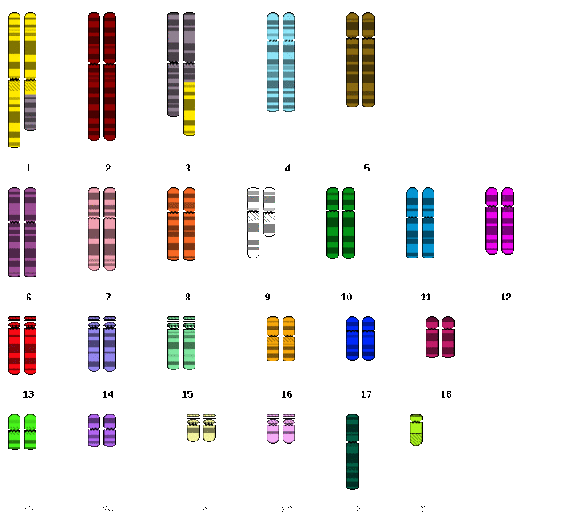

1. What are the two types of chromosomal mutations seen in the Karyotype above?
2. Translocation; Addition
3. Duplication; Inversion
4. **Translocation; Deletion**
5. Duplication; Non-disjunction
6. Tool use is providing an insight to the evolution of hominid lifestyles. Which of the following is suggested to be the main use of the Acheulian tools?
   1. To build fires.
   2. To groom.
   3. **To process meat and hides.**
   4. Undetermined.
7. In the biotechnological technique Polymerase Chain Reaction, a synthetic sequence of nucleotides is involved in which of the following steps?
   1. Denaturing
   2. Priming
   3. **Annealing**
   4. Elongation

Question 15 refers to the diagram below.

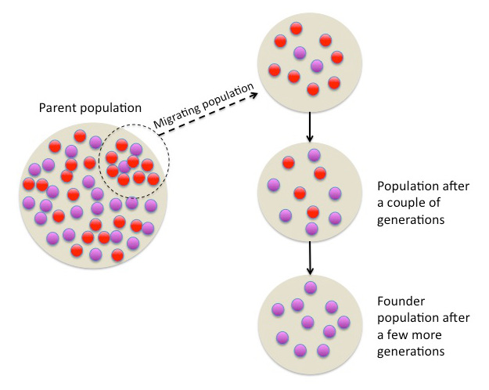

1. The diagram above is best representative of
   1. Random genetic drift
   2. **The Founder effect**
   3. Migration
   4. Natural selection
2. The somatic nervous system is responsible for
   1. Maintaining homeostasis within the internal environment.
   2. **Receiving and sending information as interaction with the outside environment.**
   3. Regulating the endocrine system.
   4. Interactions between the brain and spinal cord.
3. Which of the following species, which lived approximately 3.8 million years ago, gave rise to at least two branches of hominids: the later australopithecines and the genus *Homo*?
   1. *H. habilis*
   2. *A. africanus*
   3. *P. robustus*
   4. ***A. afarensis***

Question 18 refers the diagrams below.

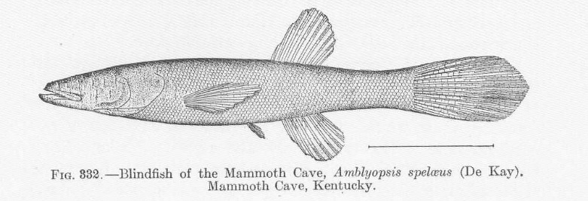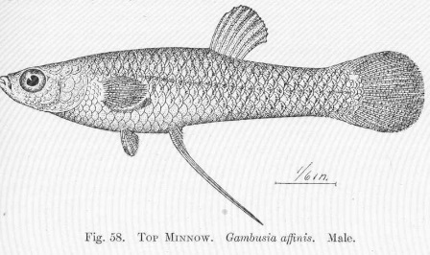

1. The Cave Fish and the Minnow are related species, but the cave fish is blind. What type of comparative study is best represented by this example?
   1. Embryology
   2. Homologous Structures
   3. **Vestigial Organs**
   4. Comparative Anatomy
2. Absolute dating methods have provided valuable information in the study of human origin. A timber circle, known as Seahenge, was discovered in 1998 off the coast of England and dated back to 2049BC. Which of the following methods would have most likely been used in this dating procedure?
   1. Stratigraphy and radiocarbon dating
   2. Dendrochronology and Fluorine dating
   3. Carbon-14 and thermoluminescence
   4. **Dendrochronology and radiocarbon dating**
3. Which of the following describes the order of processes associated with DNA Fingerprinting?
   1. **DNA Isolation 🡪 Restriction Enzymes 🡪 Electrophoresis**
   2. DNA Isolation 🡪 Electrophoresis 🡪 Restriction Enzymes
   3. Restriction Enzymes 🡪 DNA Isolation 🡪 Electrophoresis
   4. Restriction Enzymes 🡪 Electrophoresis 🡪 DNA Isolation
4. The correct order of human ancestors from oldest to youngest is
   1. ***Homo habilis, Homo erectus, Homo neanderthalensis, Homo sapiens***
   2. *Homo sapiens, Homo habilis, Homo erectus, Homo neanderthalensis*
   3. *Homo neanderthalensis, Homo habilis, Homo sapiens, Homo erectus*
   4. *Homo erectus, Homo neanderthalensis, Homo sapiens, Homo habilis*

Question 22 refers to the diagram below of primate dental arcades.

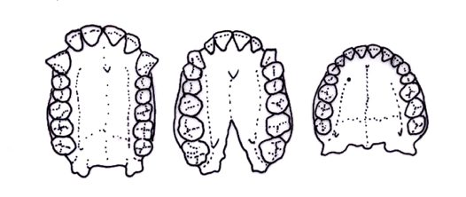

A B C

1. Primate dentition, including dental arcade, are suggested to have evolved due to dietary changes. The dental arcade of Primate C has a more parabolic pattern than Primate A because Primate A is
   1. human and requires distinct gaps between the incisors and canines.
   2. an ape and requires smaller and narrower teeth.
   3. human and requires smaller molars due to changes in diet.
   4. **an ape and requires larger molars for grinding their food.**
2. Helper T-cells play an important role in both humoral and cell-mediated immunity. Which of the following is **not** an action of Helper T-cells?
   1. Intensify the cell-mediated response.
   2. Attract macrophages to the site of infection.
   3. Increase phagocytic activity.
   4. **Migrate, attach and secrete substances to destroy pathogens.**
3. Advantages of bipedal locomotion and erect stance include all except which of the following?
   1. Free hands to carry food and for tool use
   2. **Improved heating of the body**
   3. Increased size to deter predators
   4. Increased range of vision

Questions 25 and 26 refer to the diagram below of the half-life of Potassium (K)-40.

1. Using the graph, calculate the half-life of Potassium-40.
   1. **1.3 billion years**
   2. 2.0 billion years
   3. 50 billion years
   4. 6.0 billion years
2. Potassium-40 decays into Argon-40. If a sample was found to be 3.2 billion years old, what approximate percentage of Argon-40 would be present?
   1. **80%**
   2. 90%
   3. 60%
   4. 70%
3. Within a small population, changes in gene frequencies that occur due to chance events are is known as
   1. Mutation.
   2. Natural selection.
   3. Sexual selection.
   4. **Genetic drift.**
4. Pathogens are neutralised and eliminated during acute inflammatory responses. All of the following are stages in the inflammatory response except
   1. **Clots, due to release of heparin, form to limit the spread of the pathogens.**
   2. Increased numbers of leukocytes arrive at site due to increased blood flow.
   3. Temperature of site increases to inhibit pathogen growth due to blood leakage into tissue.
   4. Phagocytes engulf and digest dead cells and pathogens producing pus.
5. Tay-Sachs disease causes the deterioration of nerve cells. Which of the following characteristics indicates that this disease has a heterozygote advantage based on Natural Selection?
   1. The disease appears in pedigrees with no known family history
   2. **Frequency is greater in the Ashkenazi Jewish population than other Caucasian populations**
   3. The disease results in death at a very young age due to the nerve damage
   4. All of the above
6. The body’s external defence mechanisms against pathogens includes features of many body systems. All of the following physical barriers can help prevent pathogens via low pH (acidity) levels except:
   1. **Respiratory system.**
   2. Urogenital tract.
   3. Digestive tract.
   4. Integumentary (skin) system.

**Section Two: Short answer 50% (100 Marks)**

This section has **seven (7)** questions. Answer **all** questions. Write your answers in the spaces provided. Spare pages are included at the end of this booklet. They can be used for planning your responses and/or as additional space if required to continue an answer.

* + Planning: If you use the spare pages for planning, indicate this clearly at the top of the page.
  + Continuing an answer: If you need to use the space to continue an answer, indicate in the original answer space where the answer is continued, i.e. give the page number. Fill in the number of the question(s) that you are continuing to answer at the top of the page.

Suggested working time: 90 minutes.

**Question 31 (8 marks)**

The endocrine system produces a variety of hormones, including the sex hormones, such as testosterone and oestrogen. These are examples of lipid-soluble hormones. Consider each of the following mechanisms of hormone action.

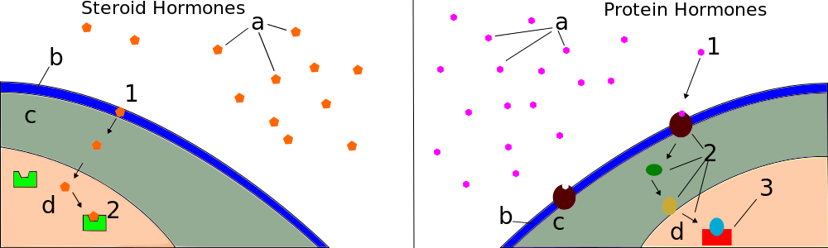

Model A Model B

1. State the model, A or B, that best corresponds to the mechanism of hormones such as testosterone and oestrogen. (1 mark)

**A**

1. State why Model B would result in short-lived responses. (1 mark)

**Intracellular signalling molecules are broken down by enzymes**

1. Hormones elicit responses via different mechanisms. State **two (2)** ways in which hormones exhibit their effects. (2 marks)

**TWO of the following:**

* **Activate genes to produce particular proteins (1)**
* **Change the shape/structure of an enzyme to turn it ‘on’ or ‘off’ (1)**
* **Change the rate of translation or transcription / change rate of protein/enzyme synthesis (1)**

1. The hypothalamus and pituitary gland are joined by a stalk called the infundibulum. State how the hypothalamus controls secretions from the anterior and posterior lobe of the pituitary gland. (2 marks)

Anterior lobe: **blood vessels (1)**

Posterior lobe: **neurosecretory cells / nerve cells / neurons (1)**

A group of volunteers were tested for plasma solute concentration, plasma antidiuretic hormone (ADH) concentration and feelings of thirst. The graph below shows the relationship between intensity of thirst, plasma ADH concentration and plasma solute concentration.

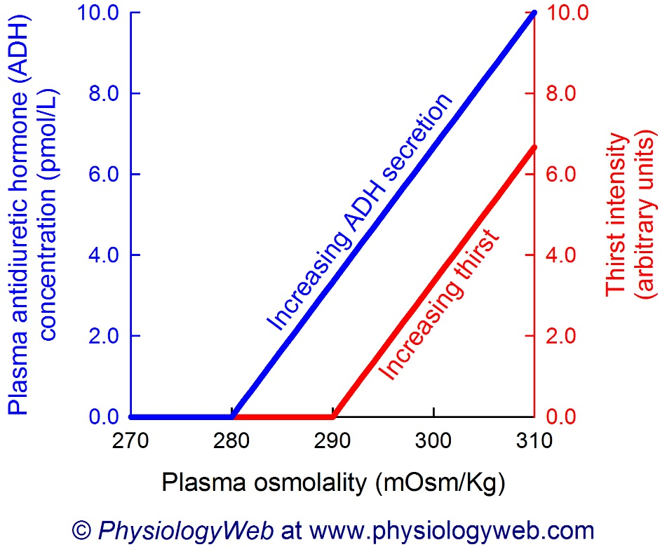

1. **The normal osmolality of extracellular fluid is 280-295 mOsmol kg-1. Identify the plasma ADH concentration at a plasma solute concentration of 295 mOsmol kg-1.**

(1 mark)

**4.5-5.5 pmol/L**

1. **Compare the intensity of thirst and plasma ADH concentration.** (1 mark)

**As plasma osmolality increases, so does the intensity of thirst.**

**Question 32 (13 marks)**

*Light for Riley* is a community campaign created after Riley Hughes, a 3 week old infant, died from Whooping Cough in a Western Australian Hospital in 2015. Since then, Riley’s mother Catherine and her husband have promoted the protection of children from vaccine-preventable diseases through the process of immunisation.

1. Describe **two (2)** different types of vaccines used, and list an example of the disease they protect against. (4 marks)

**Any two of the following:**

|  |  |
| --- | --- |
| **Living attenuated micro-organisms (1)** | **Measles / mumps / rubella / rabies / polio / tuberculosis / yellow fever (1)** |
| **Dead micro-organisms (1)** | **Cholera / bubonic plague / typhoid / whooping cough / influenza / hepatitis A (1)** |
| **Toxoids (1)** | **Diphtheria / tetanus (1)** |
| **Sub-unit (1)** | **Human papilloma virus (HPV) / Hep B (1)** |

1. Local health agencies in Western Australia suggest that Whooping Cough vaccinations be given at 2, 4 and 6 months of age. State the type of immunity and likely source of antibodies for newborns between the ages of 0 and 2 months. (2 marks)

**Natural Passive (1) enter the infant through the placenta / breast milk (1)**

A newborn baby was monitored for the presence of pertussis antibodies, with none detected for the first two months of life. The baby was then given the routine vaccinations at 2, 4 and 6 months of age.

1. On the following figure, draw a graph indicating the level of pertussis antibodies you would expect in the baby from the age of 2 to 12 months. (3 marks)

Level of Pertussis Antibodies (arbitrary units)

2 4 6 8 10 12

Time (months)

**Must show increase of antibodies at the 2, 4 and 6 months, with an overall increase in antibodies.**

1. Explain the difference between an antibody and an antigen. (2 marks)

**Antigens are substances that cause an immune response.(1)**

**Antibodies are proteins produced in response to non-self antigens.(1)**

One of the driving forces behind *Light for Riley*, is the decrease in the number of children being fully immunised. The diagram below shows a number of areas within Australia with low immunisation rates.

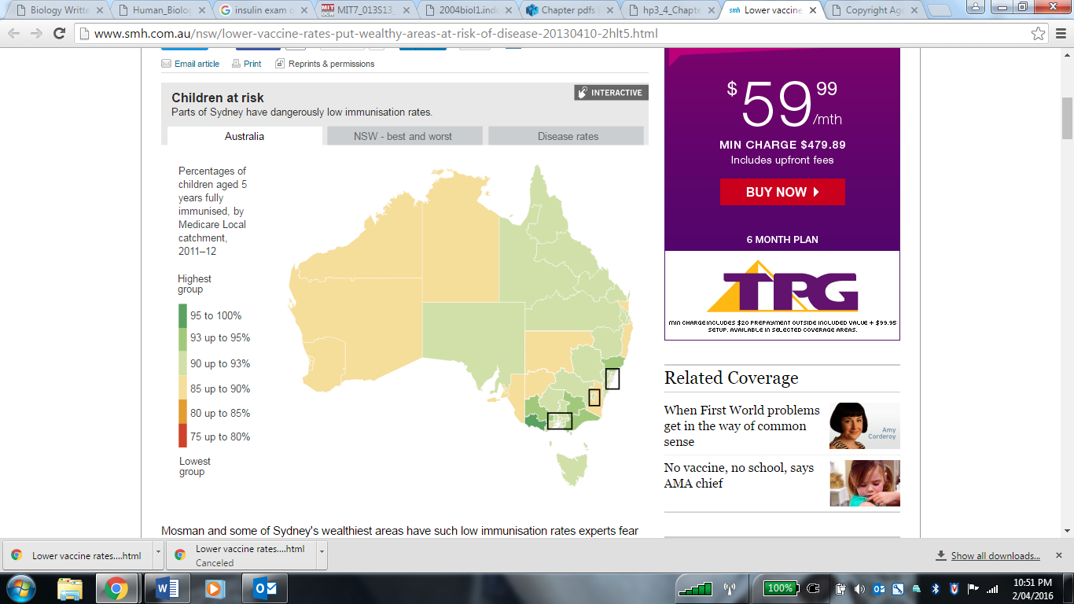

1. Discuss **one (1)** possible reason for the decline of immunisation rates in Australia.

(2 marks)

**Any ONE of the following:**

* **Risk of autism and / or other nervous system conditions (1) due to use of preservatives/chemicals (1)**
* **Risk of allergic reactions (1) due to medium in which the vaccine is cultured (i.e. egg) (1)**
* **Risk of cross-species disease introduction (1) due to being cultured in animal tissue (1)**
* **Ethical concerns (1) such as use foetal tissues to create vaccine (1)**
* **Moral issues (1) such as the young age of which Gardasil is given (1)**

**Question 33 (20 marks)**

The Human Genome Project has allowed many applications that are advantageous to human health. In 1922 it was found that insulin from cattle and pigs could be used in humans to relieve the symptoms of diabetes in humans. The problem with this form of insulin production was that there were not enough pigs to provide the quantities needed. This led to one of the biggest breakthroughs in biotechnology: the cloning of the human insulin gene.

1. Name the organ where insulin is produced, and describe the role insulin has on controlling blood sugar levels. (3 marks)

**Pancreas (1)**

**Decreases blood sugar levels (1) by increasing glucose uptake by cells / glycogenesis (1)**

1. State the biotechnology technique that has been used to produce human insulin

(1 mark)

**Recombinant DNA Technology / Genetic Engineering**

1. A transgenic organism is one which has had a foreign piece of DNA inserted into its genome artificially. State the type of transgenic organism used in the production of insulin.

(1 mark)

**Bacteria**

1. The production of a transgenic organism requires the presence of certain enzymes. Briefly explain how the following enzymes are involved in the production of a transgenic organism.

(4 marks)

Restriction enzymes:

**Cut strands of vector and gene of interest / DNA at specific sequences of nucleotides (1) producing sticky ends (1)**

Ligase:

**Combines plasmid/vector and gene of interest / DNA (1) into one single structure (1)**

1. Describe the main steps involved in producing human insulin. (4 marks)

**Isolate gene and cut it out using a restriction enzyme (1)**

**Isolate a plasmid from a bacterial cell and cut with the same type of restriction enzyme (1)**

**Splice the human DNA into the plasmid using DNA ligase enzymes to join the sticky ends (1)**

**Treat the bacterium so it takes up the recombinant plasmid, multiples and produces the protein (1)**

1. Biotechnological techniques can also provide evidence for evolution. For each of the three techniques listed below, describe the feature that enables them to be used to facilitate DNA sequencing of genomes. (3 marks)

|  |  |
| --- | --- |
| **Technique** | **Feature** |
| DNA Sequencing | **Determines the precise order of nucleotides in a sample of DNA** |
| Profiling | **Determines an individual’s DNA profile or fingerprint as a distinct series of bands** |
| Polymerase Chain Reaction | **Segments of DNA are multiplied through a series of repeated cycles** |

1. Describe **one (1)** benefit and **one (1)** risk or ethical concern that is associated with the ongoing developments in biotechnology. (4 marks)

**Benefits – Any one of the following, or other suitable answer, with appropriate description (2 marks):**

* **Production of pharmaceuticals**
* **Production of vaccines**
* **Increased food safety**
* **Reduction of certain diseases**

**Risks – Any one of the following, or other suitable answer, with appropriate description (2 marks):**

* **Affordability**
* **Stem Cell Research**
* **Protecting Human Subjects in Clinical Trials**
* **Allergies / Toxicity**

**Question 34 (17 marks)**

The transmission of nerve impulses occur via electro-chemical changes that occur where the impulse is propagated and transferred.

1. Some anticonvulsants, such as Valium (diazepam), work by allowing more chloride ions to enter a patient’s neurons, making the resting potential more negative. Explain how this would affect the ability of the neuron to generate an action potential. (2 marks)

**Lowering the resting potential requires a stronger stimuli (1) to reach the threshold and trigger an impulse (1)**

1. The disease Multiple Sclerosis (MS) damages the myelin sheath and scars the nerve cell membrane. Using your knowledge of nerve cells, explain why MS sufferers experience uncontrollable tremors. (2 marks)

**The neuron will not be able to carry the impulse correctly (1), either traveling at a slower rate and/or only transmitting occasionally (1)**

1. The nervous system is composed of two main divisions (Central Nervous System or CNS, and Peripheral Nervous System or PNS) and has three major functions. Identify which division and function of the nervous system are associated with the following by placing a tick in the appropriate boxes. (4 marks)

|  |  |  |  |  |  |
| --- | --- | --- | --- | --- | --- |
|  | **Division of the Nervous System** | | **Nervous System Function** | | |
|  | **CNS** | **PNS** | **Sensory** | **Integration** | **Motor** |
| **Visual Cortex** | **X** |  | **X** |  |  |
| **Secretion from glands** |  | **X** |  |  | **X** |

1. The CNS contains both grey and white matter. Name the part of the brain which connects the two hemispheres, and describe the type of matter from which it is made. (3 marks)

**Corpus Callosum (1)**

**White matter (1)**

**Made of myelinated fibres (1)**

1. Due to the delicate and vital nature of the brain and spinal cord, these parts of the body are heavily protected by various structures. Name **one (1)** of the structures and explain how it protects the CNS. (3 marks)

**One of the following:**

**Bone/Cranium (1) – houses the brain (1), rigid/strong (1)**

**Meninges (1) – covers entire brain (1), acts as a cushion / softens impact (1)**

**Cerebrospinal Fluid (CSF) (1) – brain immersed in CSF (1) acts as shock absorber / lessens impact / supports brain (1)**

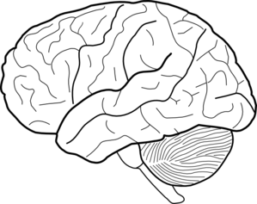

B

A

1. Referring to the diagram above, briefly explain how parts A and B work together to enable a skier to glide smoothly across the snow. (3 marks)

**Cerebrum:**

**Sensory area receives and processes information from the senses (1)**

**Motor area sends message to muscles (1)**

**Cerebellum:**

**Ensures fine coordination, posture and balance of muscle movement (1)**

**Question 35 (13 marks)**

1. Down’s syndrome and Cri-du-chat are caused by chromosomal mutations. Explain why a chromosomal mutation can result in severe effects compared to that of gene mutations.

(2 marks)

**Chromosomal mutations effect a large number of genes (1)**

**Gene mutations only affect one gene (1)**

1. The biological definition of evolution is the change of allele frequencies in a population over time. Using an example within a human population, summarise Darwin’s Theory of Evolution by Natural Selection . (6 marks)

**Variation of characteristics in a population (1)**

**More offspring produced than can survive (1)**

**Competition for survival (1)**

**Survival of the fittest (1)**

**Favourable characteristics are passed on and gene pool alters (1)**

**One mark for any suitable example including:**

* **Body stature**
* **Sickle-cell anaemia**

West Nile Virus (WNV) was first identified in 1937, and is known to lethally infect humans. Once confined to Europe, Asia, the Middle East and Africa, outbreaks are now occurring in Northern America and other Western countries. Studies have found that the protein CCR5(+) and its mutated form CCR5∆32, are associated with WNV susceptibility. The table below shows the distribution of genotypes in patients with and without WNV in Northern America.

|  |  |  |  |
| --- | --- | --- | --- |
| Genotype: | +/+ | +/∆32 | ∆32/∆32 |
| Patients with WNV | 321 | 78 | 18 |
| Patients without WNV | 155 | 16 | 2 |

1. Using the data above, the allelic frequency of **CCR5∆32** homozygotes was calculated and is stated below.

Patients with WNV: 0.04

Patients without WNV: 0.01

Given that the percentage of **CCR5∆32 homozygotes** in North America is usually 1 percent, compare frequency of **CCR5∆32 homozygotes** in both populations.

(2 marks)

**CCR5∆32 homozygotes are present at the normal frequency in population without WNV (1), but are nearly four times more common than usual in the West Nile patients (1)**

1. Propose an explanation for the data, stating whether an advantage is present.

(3 marks)

**Presence of CCR5-Δ32 increases susceptibility to WNV infection (2)**

**Low number of heterozygotes suggests no advantage (1)**

**Question 36 (15 marks)**

An experiment was conducted on the effects of exercise on breathing rate. The experiment involved subjects doing intervals of exercise which increased in length and measured their breathing rate during the rest periods. The experiment involved 30 subjects. All subjects were required to stay in a small room maintained at a temperature of 25°C and were asked to run at 8km/h on a treadmill for 30 seconds. After this, the subjects rest for 45 seconds whilst their breathing rate was measured over 15 seconds. Each interval was increased by 10 seconds until a total length of 180 seconds was reached. The results were averaged and are presented below.

|  |  |
| --- | --- |
| **Length of time of exercise (seconds)** | **Breathing Rate**  **(breaths per minute)** |
| Resting | 46 |
| 30 | 53 |
| 60 | 53 |
| 90 | 63 |
| 120 | 65 |
| 150 | 73 |
| 180 | 77 |

1. i) Propose a hypothesis for the experiment (1 mark)

**As the length of exercise increases, so does breathing rate**

ii) List **two (2)** variables that were controlled in the experiment (2 marks)

**Any two of the following:**

* + - **Speed of treadmill (8km/h)**
    - **Temperature maintained at 25deg C**
    - **Length of rest time (45sec)**

1. Suggest how researchers could increase the
   * 1. Validity of the experiment (1 mark)

**Any one of the following:**

* + - **Improve experimental design**
    - **Establish more controlled variables**
    - **Specific answer referring to the experiment**
    1. Reliability of the results (1 mark)

**Any one of the following:**

* + - **Repeat experiment again**
    - **Replicate**
    - **Increase sample size**
    - **Specific answer referring to the experiment**

1. Graph the data in the table on the grid below (5 marks)

**Correctly plots points and joins points to form a line/curve (1)**

**Labelling of X and Y axes with correct name and unit (2)**

**Uses a suitable scale (1)**

**Title appropriate with both variables included (1)**

1. Explain how increases in levels of carbon dioxide in the blood cause the breathing rate to increase over the experiment. (3 marks)

**Chemoreceptors stimulated (1) which transmit impulse to respiratory centre (1) resulting in increased activity of respiratory muscles (1)**

1. Valsalva is a technique associated with breath-holding and is often used in weight-training. Describe how this conscious control of breathing may have dangerous consequences.

(2 marks)

**Decreased Oxygen Levels in the body (1); leads to syncope / passing out (1)**

**Question 37 (14 marks)**

Scientific evidence shows that the physical and behavioural traits shared by all modern humans originated from apelike ancestors. It is believed that *Ardipithecus ramidus* was an early ancestral hominin living approximately 4.5 million years ago in what is now known as Ethiopia.

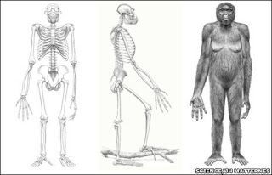

1. *Ardipithecus ramidus* has characteristics of both apes and humans. Describe **two (2)** pieces of evidence that suggests *Ardipithecus ramidus* could was bipedal. (4 marks)

**Any two of the following for two marks each:**

* + **Skull sits atop / balances on spinal cord allowing balance on two legs**
  + **Bone structure within the wrist and the shape of the palm suggest they no longer walk on their knuckles**
  + **The bowl-shaped pelvis meaning more muscle attachment to support the body upright**
  + **Angled femur so the knees sit directly under the body**

1. Four of the main hominid tool cultures are Oldowan, Acheulean, Mousterian, and Solutrean. Describe at least **two (2)** of the trends (design, manufacture, or material) in the tool cultures over time. (4 marks)

**Any two of the following:**

* **Material changed from stone, to bone and antler**
* **Design changed from hacking meat, to hunting/slaughtering (more food)**
* **Design changed to more delicate flakes, for preparing hides to live in cooler climates**
* **Manufacture from simple pebbles and stones to finely chipped**

1. Fossil remains of *A. afaransis* discovered in the 1970’s show that bipedal locomotion evolved before changes occurred in the skull. State the trend in cranial capacity between lemurs, monkeys, chimpanzees and humans, and describe an advantage of this trend. (3 marks)

**Increasing trend in cranial capacity (1)**

**Increased size of cerebral cortex (1) means improved higher-functions such as vision/ memory/reasoning/manipulative ability/behaviours (1)**

1. Explain how mitochondrial DNA provides evidence for human evolution. (3 marks)

**Passed down by mother only (1)**

**Mutation rate is proportional to amount of time that has passed (1)**

**Similarity between MtDNA estimates the closeness of the relationship (1)**

**Section Three: Extended answer 20% (40 Marks)**

This section contains **three (3)** questions. You must answer **two (2)** questions. Make sure you clearly indicate which question you are answering and write your answers in the space provided.

Spare pages are included at the end of this booklet. They can be used for planning your responses and/or as additional space if required to continue an answer.

* Planning: If you use the spare pages for planning, indicate this clearly at the top of the page.
  + Continuing an answer: If you need to use more space to continue an answer, indicate in the original answer space where the answer is continued, i.e. give the page number. Write the number of the question(s) that you are continuing to answer at the top of the additional space page.

Responses could include clearly labelled diagrams with explanatory notes; lists of points with linking sentences; clearly labelled tables and graphs; and annotated flow diagrams with introductory notes.

Suggested working time: 40 minutes.

**Question 38 (20 marks)**

Darwin voyaged on the *HMS Beagle* visiting Australia, New Zealand and the Galapagos Islands, amongst many others. He observed similarities and differences in species separated by both time and space.

1. Explain why unique species are found on remote islands, like the Galapagos, compared to islands found closer to the mainland. (8 marks)
2. Biotechnological techniques have enabled more accurate evidence for the theory of evolution.
   * 1. Briefly explain the importance of PCR, bacterial enzymes and gel electrophoresis in regards to evidence of evolution. (4 marks)
     2. Briefly describe biochemical evidence that supports the understanding that collections of species share a recent common ancestor. (4 marks)
     3. Briefly describe anatomical evidence that supports the understanding that collections of species share a recent common ancestor. (4 marks)

**QUESTION 38**

* 1. **Remote islands are isolated/geographic isolation (1), resulting in strong selection pressures to adapt to environment (1). This is no gene flow (1), with founder effect/random genetic drift (1).**

**Nearby islands share migration (1), gene flow occurs (1), minimal selection pressures/similar to mainland (1), similar niches/environments (1) so minimal chance for evolution.**

* 1. **i. PCR amplifies minute samples of DNA to testable amounts (1), gel electrophoresis facilitates DNA sequencing of genomes (1)**

**ii.**

|  |  |
| --- | --- |
| **DNA / Bioinformatics / Comparative genomics** | **All living things use the same code ATGC**  **Closer the similarity in DNA code, closer the ancestor** |
| **Mitochondrial DNA** | **Only inherited from mothers/amount of mutation roughly proportional to amount of time passed** |
| **Protein Sequences** | **Degree of similarity in sequence in amino acids** |

**iii.**

|  |  |
| --- | --- |
| **Embryology** | **Similarities of embryonic structures in early stages** |
| **Homologous Structures** | **Similarity of bone structures/anatomical similarities** |
| **Vestigial Structures** | **Structures reduced in size appearing to have no function, similar to structures still apparent in other species** |

**Question 39 (20 marks)**

The vertebral column of humans is designed to support the weight of the head and torso with minimum use of energy. This trend of S-shaped spines was noted in the earliest Australopithecines, and is a significant feature associated with bipedalism.

1. Name the **two (2)** curves that are found in the S-shaped spine, and state how they contribute to an upright stance. (4 marks)
2. Alongside skeletal changes, there has been a trend of increasing cognitive abilities and lifestyles with human evolution. Describe the significance of tool development and use for hominin evolution. (8 marks)
3. A new genetic study has revealed that genes inherited from Neanderthals 50,000 years ago have played a key role in our immune system today. Describe the events that occur in the humoral immune response and explain how the effects of invading microorganisms are overcome.

(8 marks)

**QUESTION 39**

* 1. **Lumbar (1) and cervical (1) curve bring vertebral column under centre of gravity (1) and improves body balance (1)**
  2. **Any eight (8) of the following. Focus should be on how tool development/use is connected to evolution.**

**Oldowan simple pebble tools (1) used by early Australopithecines (1) allowed exploitation of habitats (1).**

**Early homo (*H. habilis*) used stone tools for hunting (1) sharing of food occurred (1)**

***Homo erectus* used Acheulian tools such as hand axes (1) for butchering and removing animal hides (1)**

***Homo neanderthalensis* used flake tools / Mousterian (1), used to prepare animal hides and make clothes especially in the colder areas (1).**

***Homo sapiens* / Modern humans made blade tools (1) allowing for**

**Aurignacian / Cro-Magnon which were used predominantly for hunting (1).**

**Solutrean ‘laurel-leaf’ little purpose, but suggests ornamental use (1)**

**Magdalenian focusing on using bone and antler as tools which were used to make other tools (1) or to make spears / hooks (1).**

* 1. **Antigen activates B-cell / B-cell is sensitised (1)**

**B-cell enlarges and divides to produce clones (1)**

**Clones differentiate into plasma and memory cells (1)**

**Plasma cells secrete antibodies (1)**

**Memory cells remain in body tissues for secondary exposure (1)**

**Antibodies combine with antigen to form antibody-antigen complex (1)**

**Antibodies may: (any TWO of the following for 1 mark each)**

* **Inhibit reactions with cells/compounds**
* **Prevent antigen entering cell**
* **Agglutination**
* **Dissolve organisms**
* **Make antigens insoluble**
* **Coat to make for easier phagocytosis**

**Question 40 (20 marks)**

Complex neural pathways are involved in the processing of information and therefore require a certain amount of time between the recognition of a stimulus and the resulting response. For some stimuli, a reflex arc will replace this typical stimulus-response pathway.

1. Describe **two (2)** ways that reflex arcs differ from a typical transmission pathway, and suggest why reflex arcs are considered protective. (4 marks)
2. Extreme fear can result in many physical changes. Describe the nervous and hormonal changes that would take place during this experience. (8 marks)
3. Homeostasis, also known as a Neural or Autonomic Reflex, is designed to maintain a human body’s internal environment within certain limits. Describe the steps associated with maintaining concentrations of gas via the respiratory system. (8 marks)

**QUESTION 40**

1. **Difference (1 mark each, up to 2 maximum)**

**Does not involve the brain/quicker response/fewer neurons/shorter distance/ involuntary/no conscious control/no processing/less synapses**

**Protective (1 mark each, up to 2 maximum)**

**Quicker response to threats/innate/automatic response**

1. **Hormonal: adrenal medulla** 🡪 **adrenaline/noradrenaline (1), and pancreas** 🡪 **glucagon (1)**

**PLUS any 6 of the following:**

**Sympathetic stimulation Flight or fight response**

**HR increases Heart contraction strength increase**

**Bronchioles dilate Digestive Sys movement decrease**

**Liver releases glucose from glycogen Walls of bladder relax**

**Pupils dilate Sweat production increases**

**Saliva production decreases blood vessels in skin constrict**

**Blood vessels in skeletal muscle dilate blood vessels internally constrict**

1. **Either of the following:**
2. **Increase in concentration of CO2 (1) Decrease in pH level (1)**
3. **Chemoreceptors in medulla oblongata (1) chemoreceptors in aortic & carotid bodies (1)**
4. **Respiratory centre in medulla oblongata (1)**
5. **Increased activity of respiratory muscles (1)**
6. **Decrease in concentration of CO2 (1) Increase in pH level (1)**

**OR**

1. **Decrease in concentration of CO2 (1) Increase in pH level (1)**
2. **Chemoreceptors in medulla oblongata (1) chemoreceptors in aortic & carotid bodies (1)**
3. **Respiratory centre in medulla oblongata (1)**
4. **Increased activity of respiratory muscles (1)**
5. **Increase in concentration of CO2 (1) Decrease in pH level (1)**